PRACTICAL-1
Step-by-Step MinGW Installation on Windows
1. Download MinGW Installer
- Go to the official site: https://osdn.net/projects/mingw/releases/
- Find and download the mingw-get-setup.exe file.


2. Run the Installer
- Launch mingw-get-setup.exe
- Click Install (accept default installation directory, e.g., C:\MinGW)
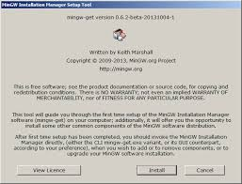
Step 3: Select Packages to Install
In the MinGW Installation Manager:
- Check the box next to:
  - mingw32-gcc-g++ (for C++ compiler)
  - mingw32-gcc-bin (compiler binaries)
  - mingw32-base (basic development tools)
  - Optionally: mingw32-gcc-objc, msys-base if needed
- Click on Installation → Apply Changes

- In the new window, click Apply to begin installation. It will download and install all selected components.

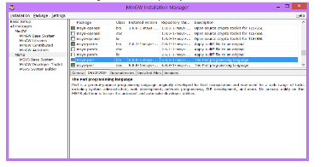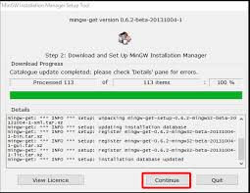

Step 4: Add MinGW to System PATH
This lets you use gcc and g++ from the command line:
- Go to:
  - Control Panel → System → Advanced System Settings → Environment Variables
- Under System variables, find and select Path, then click Edit.
- Add the path to MinGW bin folder, usually:
C:\MinGW\bin
- Click OK to close all windows.
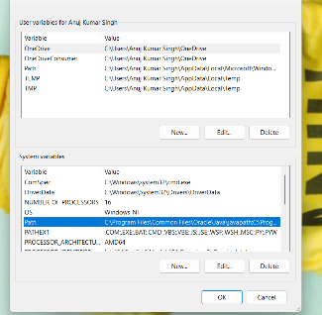
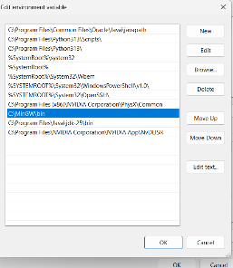
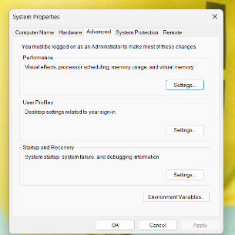
Step 5: Verify Installation
- Open Command Prompt (cmd).
- Type: gcc --version

NOW YOU SUCCESSFULLY INSTALL MINGW.

